A

Major Project On

### AI MODEL FOR DIGITAL EVALUATION OF DESCRIPTIVE ANSWERS

(Submitted in partial fulfillment of the requirements for the award of Degree) BACHELOR OF TECHNOLOGY

in

COMPUTER SCIENCE AND ENGINEERING

#### By Ch.Mahesh (197R5A0511) P.Hemanth (197R5A0509)

**A.Venkat Vijay (197R5A0512)**

Under the Guidance of

#### A. Kiran Kumar

(Assistant Professor)



**DEPARTMENT OF COMPUTER SCIENCE AND ENGINEERING**

**CMR TECHNICAL CAMPUS**

**UGC AUTONOMOUS**

(Accredited by NAAC, NBA, Permanently Affiliated to JNTUH, Approved by AICTE, New Delhi) Recognized Under Section 2(f) & 12(B) of the UGC Act.1956

Kandlakoya (V), Medchal Road, Hyderabad-501401.

**2018-22**

### DEPARTMENT OF COMPUTER SCIENCE AND ENGINEERING



**CERTIFICATE**

This is to certify that the project entitled “**AI MODEL FOR DIGITAL EVALUATION OF DESCRIPTIVE ANSWERS**” being submitted by **Ch.Mahesh(197R5A0511), P.Hemanth(197R5A0509) & A.Venkat Vijay(197R5A0512)** in partial fulfillment of the requirements for the award of the degree of B.Tech in Computer Science and Engineering to the Jawaharlal Nehru Technological University Hyderabad, is a record of bonafide work carried out by him/her under our guidance and supervision during the year 2021-22.

The results embodied in this thesis have not been submitted to any other University or Institute for the award of any degree or diploma.

**A. Kiran Kumar Dr. A. Raji Reddy**

###### (Assistant Professor) DIRECTOR

**INTERNAL GUIDE**

**Dr. K. Srujan Raju EXTERNAL EXAMINER**

###### HoD

**Submitted for viva voice Examination held on**

**ACKNOWLEDGEMENT**

Apart from the efforts of us, the success of any project depends largely on the encouragement and guidelines of many others. We take this opportunity to express our gratitude to the people who have been instrumental in the successful completion of this project. We take this opportunity to express my profound gratitude and deep regard to my guide

**A. Kiran Kumar,** Assistant Professor for his exemplary guidance, monitoring and constant encouragement throughout the project work. The blessings, help and guidance given by him shall carry us a long way in the journey of life on which we are about to embark. We also take this opportunity to express a deep sense of gratitude to Project Review Committee (PRC) **Mr. J. Narasimha Rao, Dr. T. S. Mastan Rao, Dr. Suwarna Gothane, Mr. A. Uday Kiran, Mr. A. Kiran Kumar, Mrs. G. Latha** for their cordial support, valuable information and guidance, which helped us in completing this task through various stages.

We are also thankful to **Dr. K. Srujan Raju,** Head, Department of Computer Science and Engineering for providing encouragement and support for completing this project successfully.

We are obliged to **Dr. A. Raji Reddy,** Director for being cooperative throughout the course of this project. We also express our sincere gratitude to Sri. **Ch. Gopal Reddy,** Chairman for providing excellent infrastructure and a nice atmosphere throughout the course of this project.

The guidance and support received from all the members of **CMR Technical Campus** who contributed to the completion of the project. We are grateful for their constant support and help.

Finally, we would like to take this opportunity to thank our family for their constant encouragement, without which this assignment would not be completed. We sincerely acknowledge and thank all those who gave support directly and indirectly in the completion of this project.

###### Ch.Mahesh (197R5A0511) P.Hemanth (197R5A0509)

**A.Venkat Vijay(197R5A0512)**

#### ABSTRACT

Nowadays, where the world is moving towards automation so, there is a necessity for automation in educational institutions as well. The manual system for evaluation of descriptive answers involves a lot of time & efforts of the evaluator. When the teacher evaluates any paper manually, the quality of evaluation may vary along with the emotions of the teacher. Hence, the marks distribution can sometimes be inappropriate. Our proposed system can be used instead in order to reduce their burden & allot marks equally. Our system will use machine learning to solve this problem. In Machine Learning, all result is only based on the input data provided. It will evaluate the answer based on the keywords, only one has to scan the paper then, the system will provide the marks according to the dataset present. The main aim of the project is to ensure user-friendly and more interactive software to the institution. Performing evaluation through our system will ensure uniformity in marking as the same inference mechanism will be used for all students.

### LIST OF FIGURES

|  |  |  |
| --- | --- | --- |
| **FIGURE NO** | **FIGURE NAME** | **PAGE NO** |
| Figure 3.1 | Project Architecture | 6 |
| Figure 3.2 | Use case diagram | 7 |
| Figure 3.3 | Class diagram | 8 |
| Figure 3.4 | Sequence diagram | 9 |
| Figure 3.5 | Activity diagram | 10 |

### LIST OF SCREENSHOTS

|  |  |  |
| --- | --- | --- |
| **SCREEN SHOT NO.** | **SCREEN SHOT NAME** | **PAGE NO** |
| Screenshot 5.1 | STUDENT INTERFACE | 17 |
| Screenshot 5.2 | CHECKING MAIL FORMAT | 17 |
| Screenshot 5.3 | WRITING ANSWERS | 18 |
| Screenshot 5.4 | EXAM SUBMISSION | 19 |
| Screenshot 5.5 | MARKS ALLOCATION | 19 |
| Screenshot 5.6 | DATASET COLLECTOR SNIPPET | 20 |
| Screenshot 5.7 | MODEL ANSWERS | 21 |
| Screenshot 5.8 | GIV_VAL SNIPPET | 21 |
| Screenshot 5.9 | NAV_TEST SNIPPET | 22 |

**TABLE OF CONTENTS**

|  |  |  |  |  |  |
| --- | --- | --- | --- | --- | --- |
| **ABSTRACT** | |  |  | i |  |
| **LIST OF FIGURES** | | |  | ii |  |
| **LIST OF SCREENSHOTS** | | | | iii |  |
| **1.** | **INTRODUCTION** | | | 1 |  |
|  | 1.1 | PROJECT SCOPE | | 1 |  |
|  | 1.2 | PROJECT PURPOSE | | 1 |  |
|  | 1.3 | PROJECT FEATURES | | 1 |  |
| **2.** | **SYSTEM ANALYSIS** | | | 2 |  |
|  | 2.1 | PROBLEM DEFINITION | | 2 |  |
|  | 2.2 | EXISTING SYSTEM | | 2 |  |
|  |  | 2.2.1 LIMITATIONS OF THE EXISTING SYSTEM | | 3 |  |
|  | 2.3 | PROPOSED SYSTEM | | 3 |  |
|  |  | 2.3.1 ADVANTAGES OF PROPOSED SYSTEM | | 3 |  |
|  | 2.4 | FEASIBILITY STUDY | | 3 |  |
|  |  | 2.4.1 | ECONOMIC FEASIBILITY | 4 |  |
|  |  | 2.4.2 | TECHNICAL FEASIBILITY | 4 |  |
|  |  | 2.4.3 | SOCIAL FEASIBILITY | 4 |  |
|  | 2.5 | HARDWARE & SOFTWARE REQUIREMENTS | | 5 |  |
|  |  | 2.5.1 | HARDWARE REQUIREMENTS | 5 |  |
|  |  | 2.5.2 | SOFTWARE REQUIREMENTS | 5 |  |
| **3.** | **ARCHITECTURE** | | | 6 |  |
|  | 3.1 | PROJECT ARCHITECTURE | | 6 |  |
|  | 3.2 | MODULE DESCRIPTION | | 6 |  |
|  |  |  |  |  |
|  | 3.3 | USE CASE DIAGRAM | | 7 |  |
|  |  |  |  |  |
|  | 3.4 | CLASS DIAGRAM | | 8 |  |
|  | 3.5 | SEQUENCE DIAGRAM | | 9 |  |
|  | 3.6 | ACTIVITY DIAGRAM | | 10 |  |

|  |  |  |  |  |  |
| --- | --- | --- | --- | --- | --- |
| **4.** | **IMPLEMENTATION** | | | 11 |  |
|  | 4.1 | SAMPLE CODE | | 11 |  |
| **5.** | **SCREENSHOTS** | | | 17 |  |
| **6.** | **TESTING** | |  | 23 |  |

|  |  |  |  |
| --- | --- | --- | --- |
| 6.1 | INTRODUCTION TO TESTING | | 23 |
| 6.2 | TYPES OF TESTING | | 23 |
|  | 6.2.1 | UNIT TESTING | 23 |
|  | 6.2.2 | INTEGRATION TESTING | 23 |
| 6.3 | 6.2.3 | FUNCTIONAL TESTING | 24 |
|  | TEST CASES | | 24 |
|  | 6.3.1 | Uploading Videos | 24 |
|  | 6.3.2 | Detection | 24 |
| **7. CONCLUSION & FUTURE SCOPE** | | | 25 |
| 7.1 | PROJECT CONCLUSION | | 25 |
| 7.2 | FUTURE SCOPE | | 25 |
| 1. **REFERENCES** | |  |  |
| 8.1 | REFERENCES | | 26 |
| 8.2 | WEBSITES | | 26 |

# 1.INTRODUCTION

AI MODEL FOR DIGITAL EVALUATION OF DESCRIPTIVE ANSWERS

### 1.INTRODUCTION

#### PROJECT SCOPE

Computer based evaluation of student answer is the common work which is used in many areas in assessment of students learning process. The computer assisted assessment system is developed to evaluate the one word answer such as of multiple choice questions. And can also evaluate the paragraph answer such as descriptive answer based on the keyword matching. This system can be widely used in academic institutions for checking answer sheets. It can also be implemented in different organizations which conduct competitive examinations. Student writes answer on answer-sheet. The system will take scanned copy of the answer as an I/P & then after the preprocessing step it will extract the text of the answer. Model answer sets will be provided by the moderator/evaluator. This model answers will be then trained. The evaluator also provides with the keywords and Question Specific Things. Model answer sets and keywords categorized as mentioned will be the input as well. This system is based on three parameters i.e. Keywords, Grammar and Question Specific Things.

##### PROJECT PURPOSE

The revolution in technology reduces the effort of manpower in many of the areas. the boon of the technology and rapid advancements in education industry has provided a good learning environment. It offers qualification and credits at the desktop through online courses and evaluation. The prevailing system has its own pause in terms of volume, staffing, variation in the strategies of assessing. As of now, the objective-type questions alone can be practiced and assessed through online examination.

##### PROJECT FEATURES

The main features of this project are that the designer now functions as a problem solver and tries to sort out the difficulties that the Evaluators faces. The solutions are given as proposals. The proposal is then weighed with the existing system analytically and the best one is selected. The aim of the project is to propose a system which will evaluate student performance on the basis of the descriptive answers. In order to accomplish this, we will take handwritten scanned answer sheet of descriptive answers from students. The scanned answer sheet, keywords, minimum length of the answer will be provided by the moderator as input to the system.

## 2.SYSTEM ANALYSIS

AI MODEL FOR DIGITAL EVALUATION OF DESCRIPTIVE ANSWERS

### 2.SYSTEM ANALYSIS

#### 2.SYSTEM ANALYSIS

System Analysis is the important phase in the system development process. the System is studied to the minute details and analysed. The system analyst plays an important role of an interrogator and dwells deep into the working of the present system. In analysis, a detailed study of these operations performed by the system and their relationships within and outside the system is done. A key question considered here is, “what must be done to solve the problem?” The system is viewed as a whole and the inputs to the system are identified. Once analysis is completed the analyst has a firm understanding of what is to be done.

##### PROBLEM DEFINITION

The manual system for evaluation of Descriptive Answers for technical subjects involves a lot of time and effort of the evaluator. Descriptive answers have various parameters upon which they can be evaluated such as the question specific content and writing style. Evaluating subjective answers is a critical task to perform. When human being evaluates anything, the quality of evaluation may vary along with the emotions of the person. This system can be used instead in order to reduce their burden. It will save a lot of effort and time on teacher’s part. The human efforts applied in this repetitive task can be saved and spent more in other academic endeavors. The obvious human mistakes can be reduced to obtain an unbiased result. The system calculates the score and provides results fairly quickly

##### EXISTING SYSTEM

There are many existing evaluating systems which were divided into three main phases which includes prediction of best answers for short questions using NLP, essay type long answer evaluation using tools and technologies such as sentence splitting, POS tagging, wordnet and tokenizing. In the final phase, an approach for qualitative evaluation of structured answers using keyword analysis and sentence analysis is explained. Another technique to evaluate descriptive answers by matching keywords in an answer key to the keywords and phrases in the answer base.

AI MODEL FOR DIGITAL EVALUATION OF DESCRIPTIVE ANSWERS

#### LIMITATIONS OF EXISTING SYSTEM

* + - * Time consuming.
      * Tedious process.
      * The existing systems are only capable of evaluating MCQ type questions and there is a need for a system to evaluate subjective answers.

To avoid all these limitations and make the working more accurately the system needs to be implemented efficiently.

#### PROPOSED SYSTEM

The proposed system AI comes with the opportunity of making a tedious and tiresome task in the field of education more efficient and less time consuming. The use of artificial intelligence to get optimized solutions in the form of marks obtained by the student is the core principle of the proposed system. The input answer sheets of the student will get compared to the model answer sheet by the evaluator and will then generate the final score based on multiple parameters. The various parameters will be sentence splitting, Jaccard similarity, grammar checking and sentence similarity. In this system OCR will be used to convert handwritten student answers into digital letters. Splitting the model answer and student answer into sentences and then applying Jaccard similarity, grammar checking and algorithm for sentence similarity using BERT on both the texts. Assigning marks based on weighted average and displaying the score obtained by the student.

#### ADVANTAGES OF THE PROPOSED SYSTEM

The system is very simple in design and to implement. The system requires very low system resources and the system will work in almost all configurations. It got following features

* + - * It is faster and effective than the previous existing system.
      * Better service.
      * Minimum time required.
      * Artificial intelligence can help tackle this by not omitting human errors.

#### FEASIBILITY STUDY

The feasibility of the project is analysed in this phase and business proposal is put forth with a very general plan for the project and some cost estimates. During system analysis the feasibility study of the proposed system is to be carried out. This is to ensure that the proposed system is not a burden to the company. Three key considerations involved in the feasibility analysis are

AI MODEL FOR DIGITAL EVALUATION OF DESCRIPTIVE ANSWERS

* Economic Feasibility
* Technical Feasibility
* Social Feasibility

#### ECONOMIC FEASIBILITY

The developing system must be justified by cost and benefit. Criteria to ensure that effort is concentrated on project, which will give best, return at the earliest. One of the factors, which affect the development of a new system, is the cost it would require.

The following are some of the important financial questions asked during preliminary investigation:

* + - * The costs conduct a full system investigation.
      * The cost of the hardware and software.
      * The benefits in the form of reduced costs or fewer costly errors.

Since the system is developed as part of project work, there is no manual cost to spend for the proposed system. Also all the resources are already available, it give an indication of the system is economically possible for development.

#### TECHNICAL FEASIBILITY

This study is carried out to check the technical feasibility, that is, the technical requirements of the system. Any system developed must not have a high demand on the available technical resources. The developed system must have a modest requirement, as only minimal or null changes are required for implementing this system.

#### BEHAVIOURAL FEASIBILITY

This includes the following questions:

* + - * Is there sufficient support for the users?
      * Will the proposed system cause harm?

The project would be beneficial because it satisfies the objectives when developed and installed. All behavioural aspects are considered carefully and conclude that the project is behaviourally feasible.

AI MODEL FOR DIGITAL EVALUATION OF DESCRIPTIVE ANSWERS

#### HARDWARE & SOFTWARE REQUIREMENTS

#### HARDWARE REQUIREMENTS:

Hardware interfaces specifies the logical characteristics of each interface between the software product and the hardware components of the system. The following are some hardware requirements.

* + - * Processor : Intel i3 or above.
      * Hard disk : 100GB and Above.
      * RAM : 4GB and Above.
      * Monitor : 5 inches or above.

#### SOFTWARE REQUIREMENTS:

Software Requirements specifies the logical characteristics of each interface and software components of the system. The following are some software requirements,

* + - * Operating system : Windows 7,8,10
      * Language : Python
      * IDE : PyCharm

## 3. ARCHITECTURE

AI MODEL FOR DIGITAL EVALUATION OF DESCRIPTIVE ANSWERS

### 3.ARCHITECTURE

#### PROJECT ARCHITECTURE

This project architecture shows the procedure followed for AI Model for Digital Evaluation of Descriptive Answers

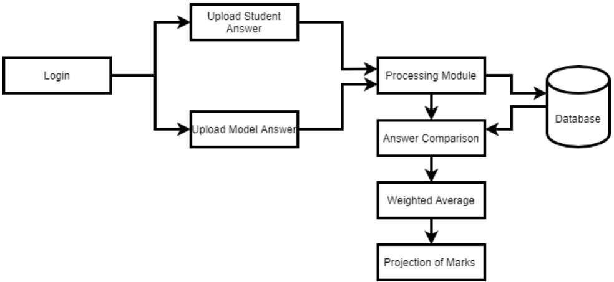

Figure 3.1: Project Architecture

AI MODEL FOR DIGITAL EVALUATION OF DESCRIPTIVE ANSWERS

#### MODULE DESCRIPTION

**Login:**  The admin is authenticated using his user id and password. Once authentication is done, the admin can add questions and their respective answers in the database. The admin can also add subjects, students and tests for those students. The admin needs to keep all the keywords from the answer in capital letters. The user logs in with test test link given by the admin password If all the credentials are satisfied then the student is redirected to the page where the question and a text box for the answer is displayed. The user can then write the answer for the question displayed. After completing the answer, he or she can submit the answer for evaluation.

**Upload Answers:** The students answers are uploaded and sent to Processing Module and the Model Answers are also uploaded and sent to Processing Module.The answer is a subjective response from the student that is to be evaluated. It usually contains some or all of the keywords and spans 1 to a few sentences depending on the type of question and the student’s writing style. It almost always contains synonym words compared to the solution and, therefore,requires much more semantic care when processing.

**Processing Module**: In this Module the Answers are Processed and sent to Database After taking inputs from the user, both the solution and the answer go through some preprocessing steps, which involve tokenization, stemming, lemmatization, stop words removal,case folding, ﬁnding, and attaching synonyms to the text

**Database:** Database is used to store the data and to get data when required. Here in this data base the model answer is uploaded by the admin and the solution which is uploaded bay the student is also stored these model answers and the solutions are further used to train the model and evaluate the solutions subbmitted by the student. The database also stores the marks secured by the students .

**Answer Comparison:** The Student Answers and Model Answers are Compared in this Module.After taking inputs from the user, both the solution and the answer go through some preprocessing steps, which involve tokenization, stemming, lemmatization, stop words removal,case folding, ﬁnding, and attaching synonyms to the text

**Results**: In this Module the Answers are Weighted and Marks are Projected to the User. It takes input from the learning module and validates the overall score with the class obtained from the learning module.Suppose the class matches the score. The score is considered ﬁnalized. If the class does not match the score, then the addition or deduction of half the number of values in that range is made based on whether the model suggested score is greater or lesser than the Similarity equivalent score

AI MODEL FOR DIGITAL EVALUATION OF DESCRIPTIVE ANSWERS

#### USE CASE DIAGRAM

In the use case diagram we have basically one actor that is user. The user has the rights to login, access to resources and to view the details.

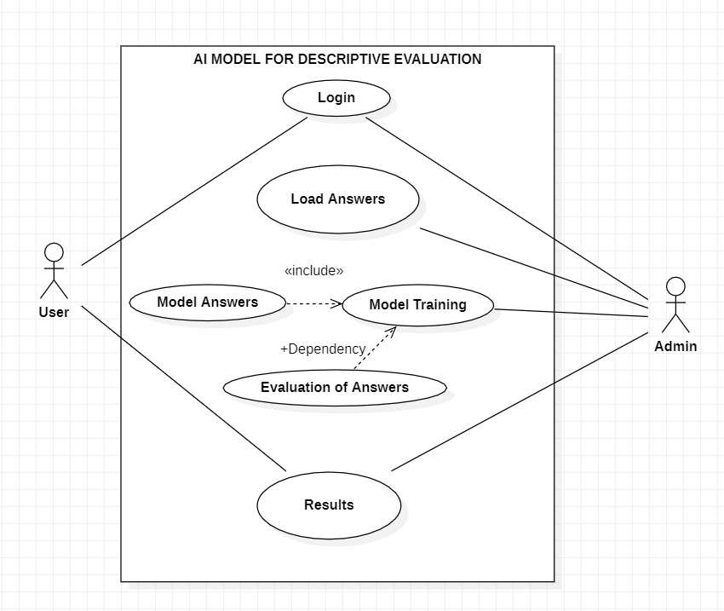Figure 3.2: Use Case Diagram of AI Model for Digital Evaluation of Descriptive Answers

AI MODEL FOR DIGITAL EVALUATION OF DESCRIPTIVE ANSWERS

#### CLASS DIAGRAM

Class Diagram is a collection of classes and objects.

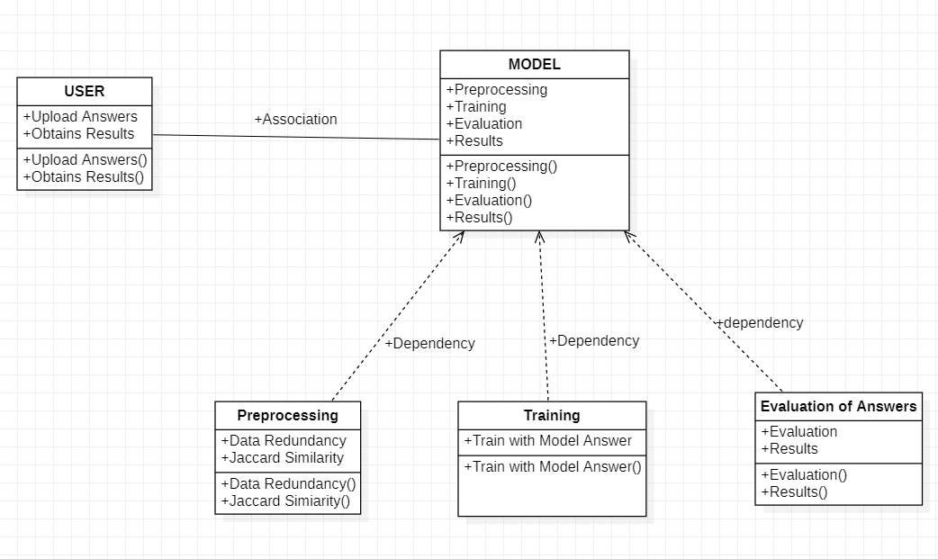

Figure 3.3: Class Diagram of AI Model for Digital Evaluation of Descriptive Answers.

AI MODEL FOR DIGITAL EVALUATION OF DESCRIPTIVE ANSWERS

#### SEQUENCE DIAGRAM

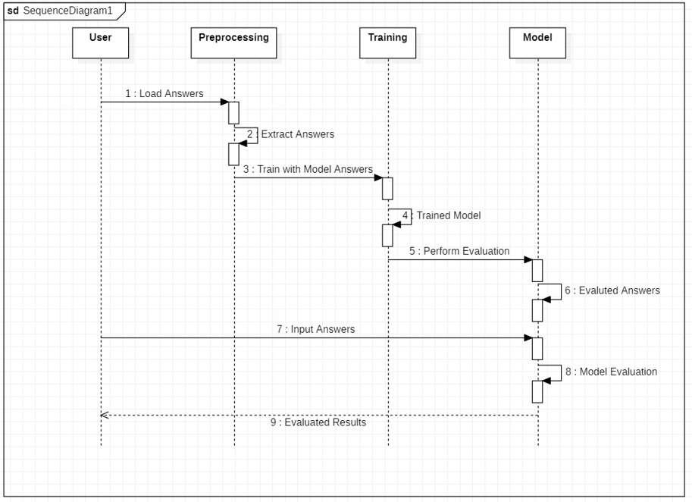

Figure 3.4: Sequence Diagram of AI Model for Digital Evaluation of Descriptive Answers

AI MODEL FOR DIGITAL EVALUATION OF DESCRIPTIVE ANSWERS

#### ACTIVITY DIAGRAM

It describes about flow of activity states.

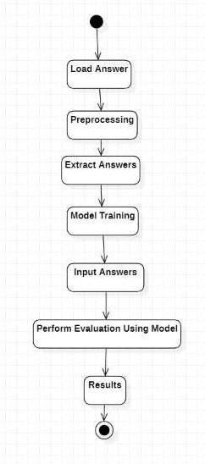

Figure 3.5: Activity Diagram of AI Model for Digital Evaluation of Descriptive Answers.

**4. IMPLEMENTATION**

AI MODEL FOR DIGITAL EVALUATION OF DESCRIPTIVE ANSWERS

**4.IMPLEMENTATION**

**4.1 SAMPLE CODE**

from flask import Flask, render_template, request

import json

import os

app = Flask(__name__)

email = "null"

@app.route('/')

def Base_qstn_paper_set():

return render_template('first.html')

@app.route('/foo', methods=['POST', 'GET'])

def foo():

if request.method == 'POST':

first = request.form['first']

second = request.form['second']

hird = request.form['third']

email = request.form['emailID']

ans = {"a1": first, "a2": second, "a3": third, "email": email}

json_object = json.dumps(ans, indent=4)

if os.path.exists("data/"+email+"mahesh@gmail.com.json")==False:

with open("data/" + email + "mahesh@gmail.com.json", "w") as outfile:

outfile.write(json_object)

return render_template('Exam_end.html')

else:

return render_template('exist_student.html')

if __name__ == '__main__':

app.run()

AI MODEL FOR DIGITAL EVALUATION OF DESCRIPTIVE ANSWERS

import json

import os

import math

import re

import pandas as pd

import nav_test

from fuzzywuzzy import fuzz

# TODO- Accuracy prediction library

'''

e = 1

vg = 2

g = 3

o = 4

p = 5

vp = 6

Grammar:

y = 1

n = 0

def givVal(model_answer, keywords, answer, out_of):

# KEYWORDS =>>>>>>>>>>>>>>>>>>>>>>>>>>>>>>>>>>>>>>>>>>

# TODO : Enhacnce this thing

if (len(answer.split(" "))) <= 5:

return 0

count = 0

keywords_count = len(keywords)

for i in range(keywords_count):

if keywords[i] in answer:

count = count + 1

AI MODEL FOR DIGITAL EVALUATION OF DESCRIPTIVE ANSWERS

k = 0

if count == keywords_count:

k = 1

elif count == (keywords_count -1):

k = 2

elif count == (keywords_count -2):

k = 3

elif count == (keywords_count - 3):

k = 4

elif count == (keywords_count - 4):

k = 5

elif count == (keywords_count - 5):

k = 6

g=1

# QST =>>>>>>>>>>>>>>>>>>>>>>>>>>>>>>>>>>>>>>>>>>>>>>>

#print("fuzz1 ratio: ", fuzz.ratio(model_answer, answer))

q = math.ceil(fuzz.token_set_ratio(model_answer, answer) * 1 / 100)

#print("Keywords : ", k)

#print("Grammar : ", g)

#print("QST : ", q)

predicted = nav_test.predict(k, g, q)

# Mathematical model->

# predicted / 10

# what? / out_of

result = predicted * out_of / 10

return result[0]

dat=[]

directory = "../temp"

AI MODEL FOR DIGITAL EVALUATION OF DESCRIPTIVE ANSWERS

for filename in os.listdir(directory):

f = os.path.join(directory, filename)

if os.path.isfile(f):

x = open(f, 'r', encoding="cp866")

dat.append(json.load(x))

model_answer1 = dat[0]['answer']

out_of1 = dat[0]['out_of']

keywords1 =dat[0]['keywords']

keywords1 = re.findall(r"[a-zA-Z]+", keywords1)

model_answer2 = dat[1]['answer']

out_of2 = dat[1]['out_of']

keywords2 =dat[1]['keywords']

keywords2 = re.findall(r"[a-zA-Z]+", keywords2)

model_answer3 = dat[2]['answer']

out_of3 = dat[2]['out_of']

keywords3 =dat[2]['keywords']

keywords3 = re.findall(r"[a-zA-Z]+", keywords3)

keywords=[keywords1,keywords2,keywords3]

directory="../DataSetCollectorFlaskApp/data"

result=0

AI MODEL FOR DIGITAL EVALUATION OF DESCRIPTIVE ANSWERS

model_answers=[model_answer2,model_answer2,model_answer3]

out_ofs=[out_of1,out_of2,out_of3]

studentReport=[]

StudentEmail=[]

StudentMarks=[]

marksperQ=[]

for filename in os.listdir(directory):

f = os.path.join(directory, filename)

if os.path.isfile(f):

x=open(f)

data = json.load(x)

result=0

answers=[data['a1'],data['a2'],data['a3']]

results = []

for xx in range(3):

results.append(result)

result =result+ givVal(model_answers[xx], keywords[xx], answers[xx], out_ofs[xx])

StudentMarks.append(result)

StudentEmail.append(data["email"])

marksperQ.append(results)

ToatalReport=pd.DataFrame(list(zip(StudentEmail,StudentMarks)))

AI MODEL FOR DIGITAL EVALUATION OF DESCRIPTIVE ANSWERS

ToatalReport.columns = ['Student Name','Total Marks']

ToatalReport.index +=1

print(ToatalReport)

{ "answer":

"Encapsulation is an object-oriented programming concept that binds together the data and functions that manipulate the data, and that keeps both safe from outside interference and misuse.Data encapsulation led to the important OOP concept of data hiding. If a class does not allow calling code to access internal object data and permits access through methods only, this is a strong form of abstraction or information hiding known as encapsulation. Data encapsulation is a mechanism of bundling the data, and the functions that use them and data abstraction is a mechanism of exposing only the interfaces and hiding the implementation details from the user. Abstraction and encapsulation are complementary concepts: abstraction focuses on the observable behavior of an object. encapsulation focuses upon the implementation that gives rise to this behavior. encapsulation is most often achieved through information hiding, which is the process of hiding all of the secrets of object that do not contribute to its essential characteristics. Encapsulation is the process of combining data and functions into a single unit called

class. In Encapsulation, the data is not accessed directly; it is accessed through the functions present inside

the class. In simpler words, attributes of the class are kept private and public getter and setter methods are provided to manipulate these attributes. Thus, encapsulation makes the concept of data hiding possible Abstraction is a process where you show only “relevant” data and “hide” unnecessary details of an object from the user.",

"keywords": "['binds', 'together', 'relevant data', 'data hiding', 'data hiding', 'abstraction', 'combining data']"

, "out_of": 5

}

{

"answer":

"Asymptotic Notations are languages that allow us to analyze an algorithm's running time by identifying its behavior as the input size for the algorithm increases. This is also known as an algorithm's growth rate. Main Types - 1. Big 2.Small 1. Big Notation further divided into three types- 1)Big O 2)Big Omega 3)Big Theta 2. Small Notation further divided into three types- 1)Small o 2)Small Theta",

"keywords": "['Analysing Algorithm', 'analyse running time','represent time complexity of algorithms','measure the efficiency']",

"out_of": 5

}

{

AI MODEL FOR DIGITAL EVALUATION OF DESCRIPTIVE ANSWERS

AI MODEL FOR DIGITAL EVALUATION OF DESCRIPTIVE ANSWERS

"answer": "Polymorphism means to process objects differently based on their data type. In other words it means, one method with multiple implementation, for a certain class of action. And which implementation to be used is decided at runtime depending upon the situation (i.e., data type of the object) This can be implemented by designing a generic interface, which provides generic methods for a

certain class of action and there can be multiple classes, which provides the implementation of these generic methods. In object-oriented programming, polymorphism refers to a programming language&#39;s ability to process objects differently depending on their data type or class. More specifically, it is the ability to redefine methods for derived classes. 1) Static Polymorphism also known as compile time polymorphism - Polymorphism that is resolved during compiler time is known as static polymorphism. Method overloading is an example of compile time polymorphism.2) Dynamic Polymorphism also known as runtime polymorphism - It is also known as Dynamic Method Dispatch. Dynamic polymorphism is a process in which a call to an overridden method is resolved at runtime, that is why it is called runtime polymorphism.",

"keywords": "['one name many forms' , 'generic interface', 'implementation', 'runtime', 'same method name', 'same function name']",

"out_of": 5

}

from sklearn.naive_bayes import GaussianNB

import pandas as pd

import numpy as np

import pickle

df = pd.read_csv('finaldataset.csv')

xf = df[['keyword', 'grammar', 'qst']]

# intigrate keyword, grammar, qst :)

''''

AI MODEL FOR DIGITAL EVALUATION OF DESCRIPTIVE ANSWERS

keywords and qst:

e = 1

vg = 2

g = 3

o = 4

p = 5

vp = 6

Grammar:

y = 1

n = 0

class labels 0.1 to 0.9 simplifies to 0 to 9 for calculation purpose

'''

x = np.array(xf.values)

yf = df[['class']]

y = np.array(yf.values).ravel()

clf = GaussianNB()

clf.fit(x,y)

with open('nav_test.pickle','wb') as f:

pickle.dump(clf, f)

pickle_in = open('nav_test.pickle', 'rb')

clf = pickle.load(pickle_in)

def predict(k, g, q):

predicted = clf.predict([[k, g, q]])

accuracy = clf.predict_proba([[k, g, q]])

#print("class[1-9] : " + str(predicted))

#print(accuracy)

print(np.max(accuracy))

return predicted

**5. SCREEN SHOTS**

AI MODEL FOR DIGITAL EVALUATION OF DESCRIPTIVE ANSWERS

**5. SCREEN SHOTS**

**5.1 STUDENT INTERFACE**

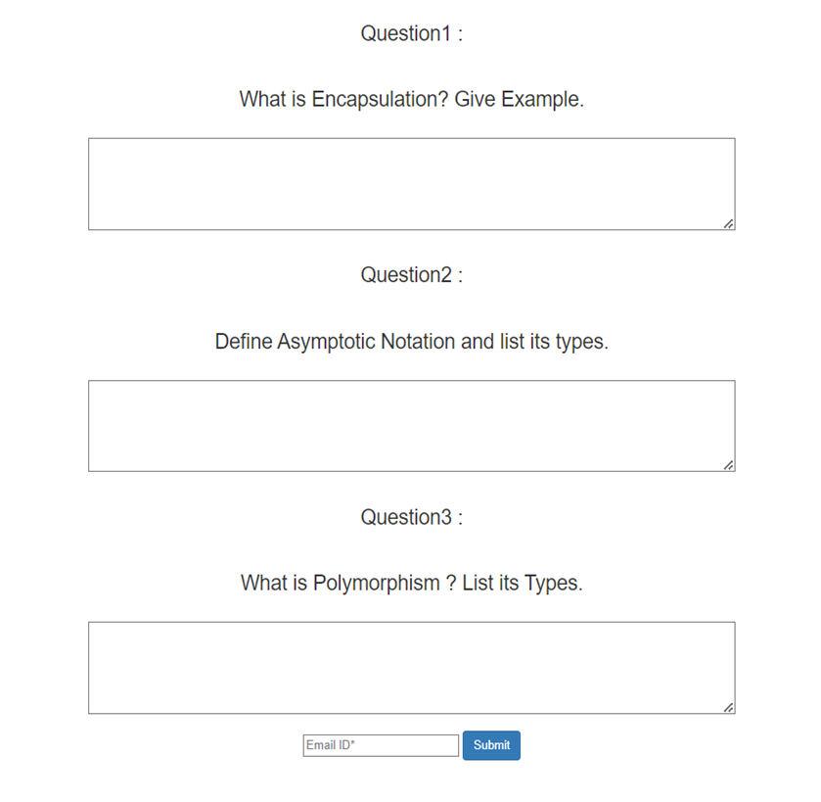

**5.2 CHECKING MAIL FORMAT**

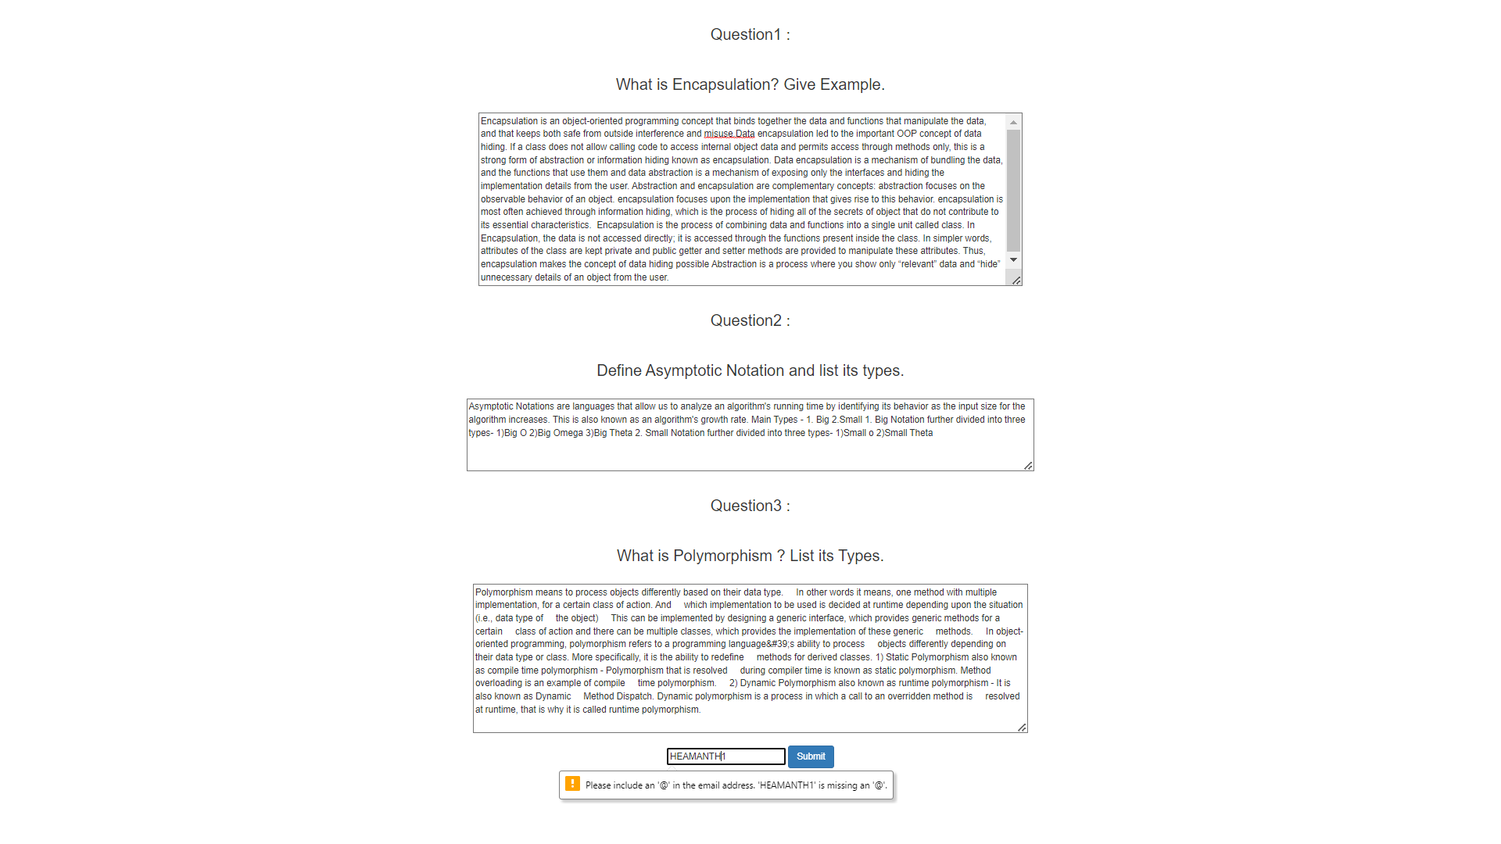

**5.3 WRITING ANSWERS**

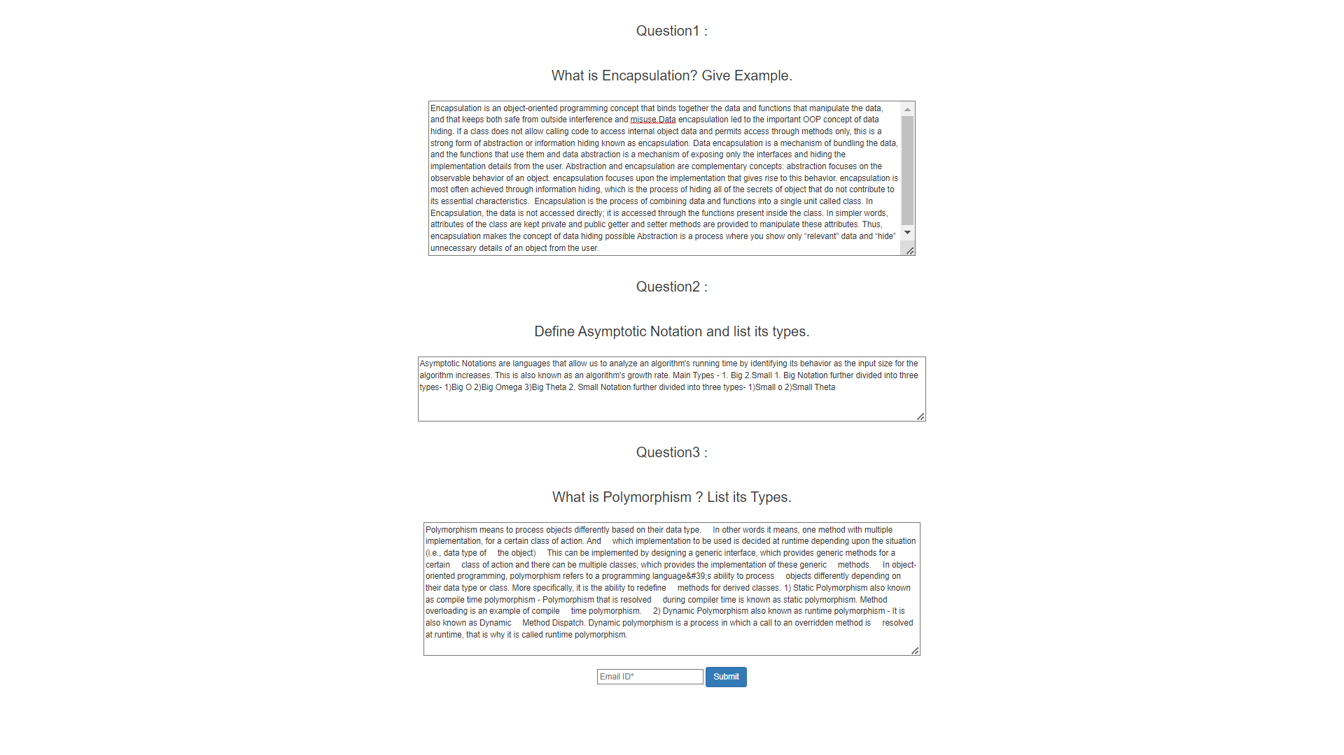

### 5.4. EXAM SUBMISSION

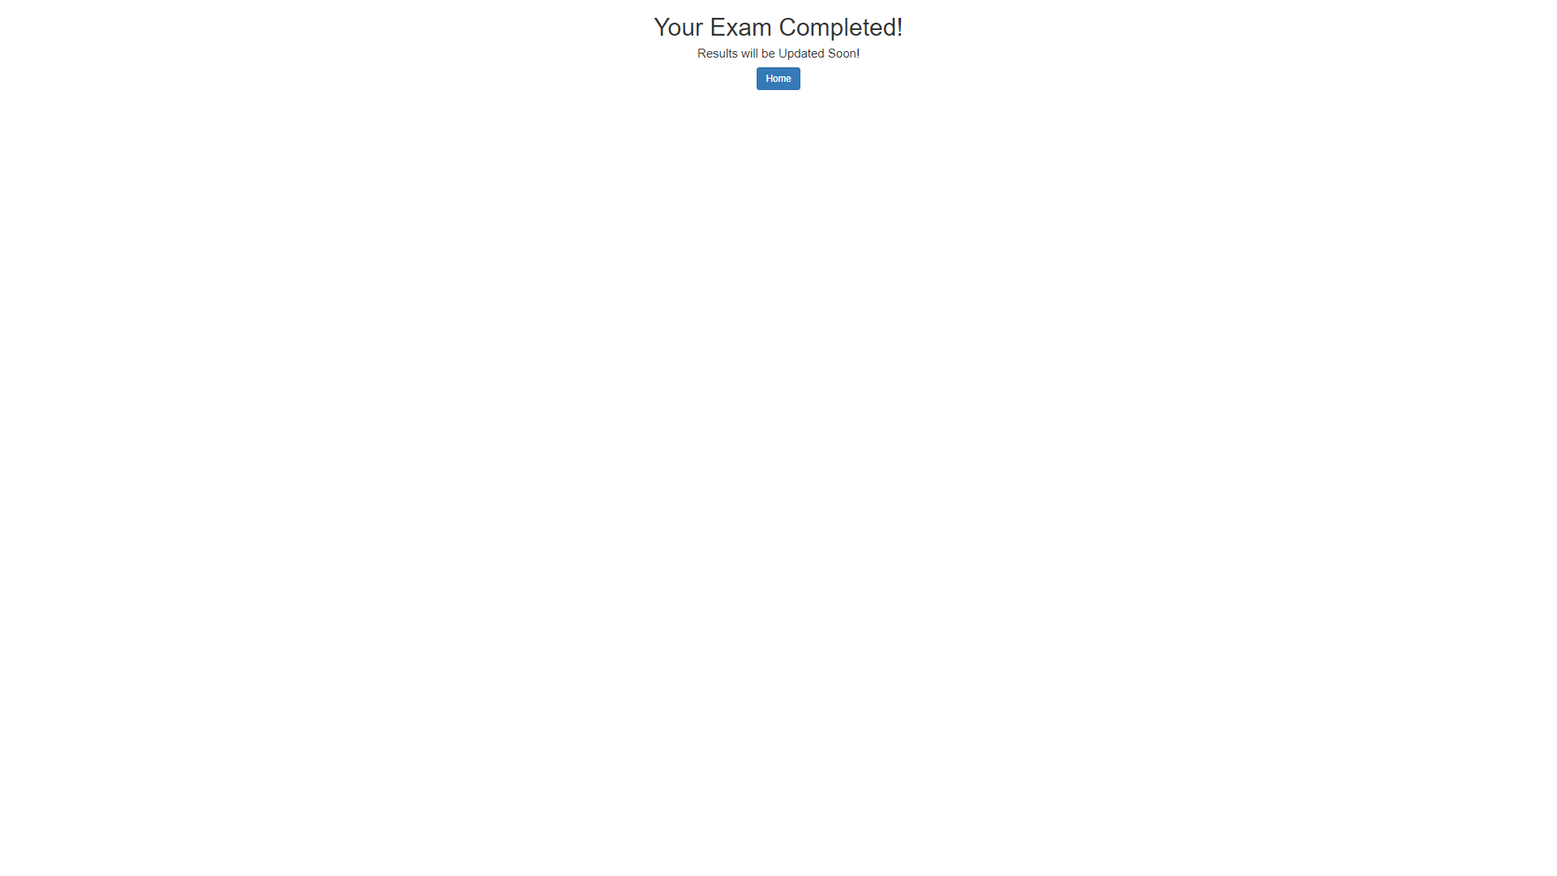

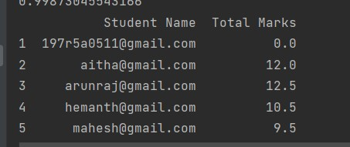**5.5 MARKS ALLOCATION**

AI MODEL FOR DIGITAL EVALUATION OF DESCRIPTIVE ANSWERS

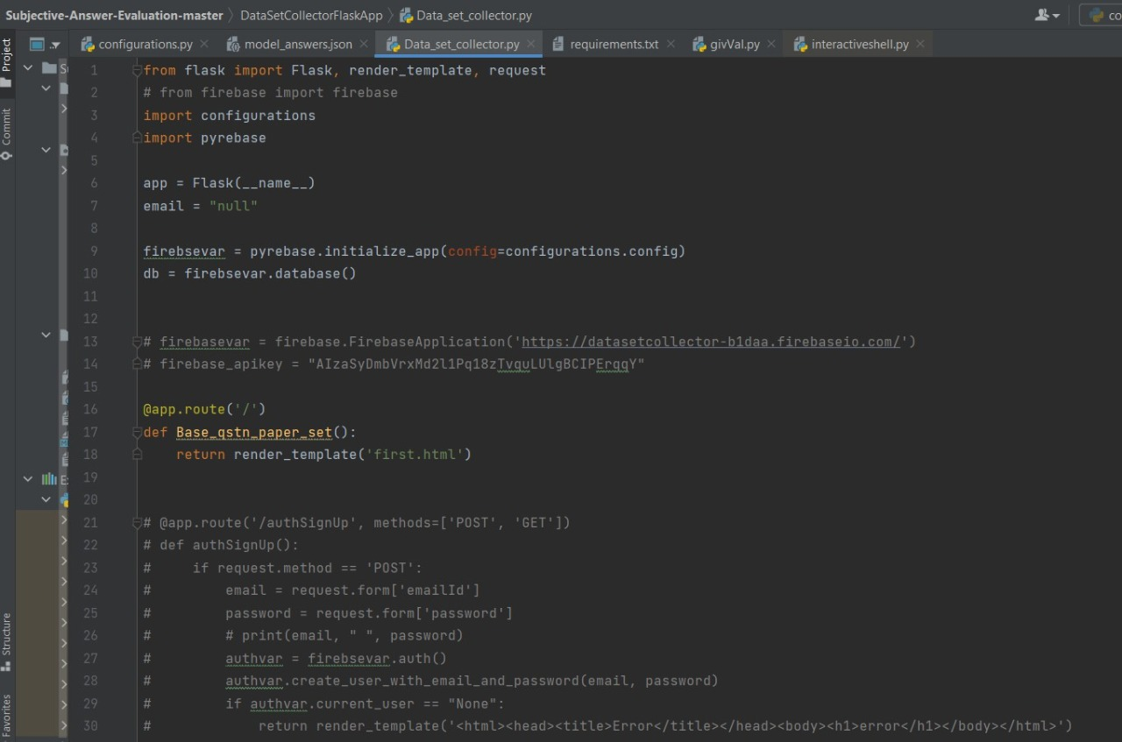

**5.6 DATA SET COLLECTOR SNIPPET**

AI MODEL FOR DIGITAL EVALUATION OF DESCRIPTIVE ANSWERS

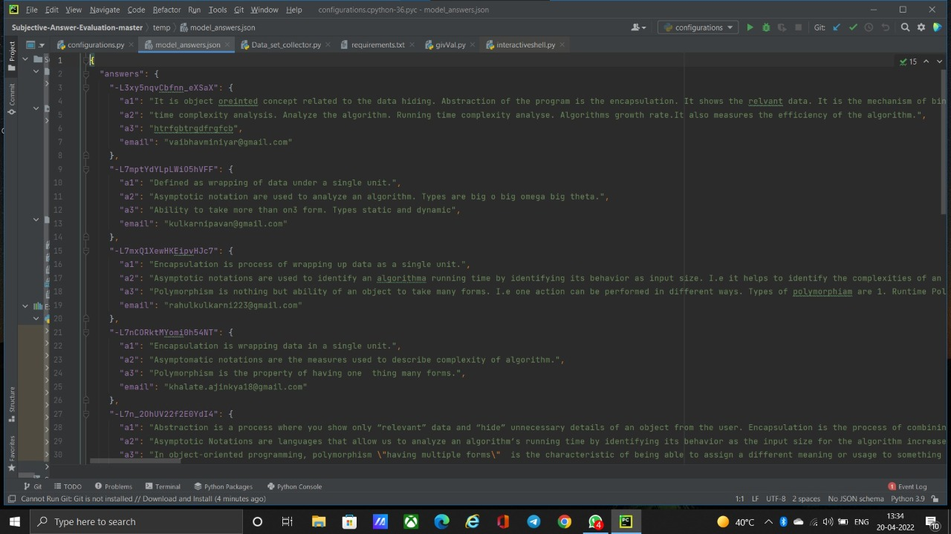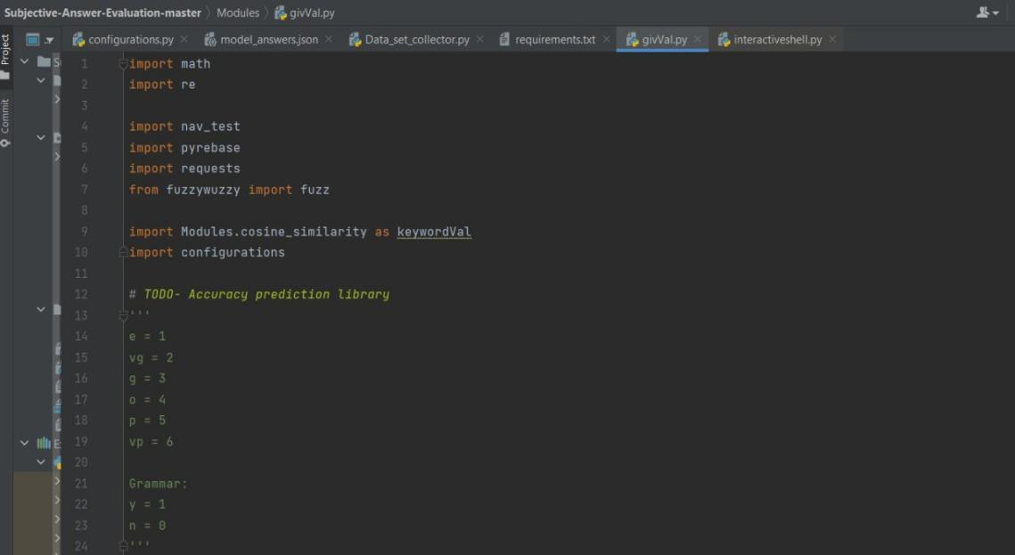 **5.7 MODEL ANSWERS**

**5.8 GIV_VAL SNIPPET**

AI MODEL FOR DIGITAL EVALUATION OF DESCRIPTIVE ANSWERS

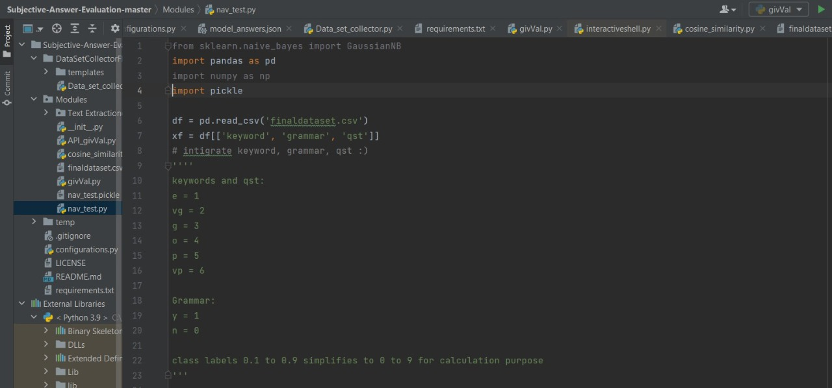**5.9 NAV_TEST SNIPPET**

**6. TESTING**

AI MODEL FOR DIGITAL EVALUATION OF DESCRIPTIVE ANSWERS

**6. TESTING**

**6.1 INTRODUCTION TO TESTING**

The purpose of testing is to discover errors. Testing is the process of trying to discover very conceivable fault or weakness in a work product. It provides a way to check the functionality of components, sub-assemblies, assemblies and/or a finished product. It is the process of exercising software with the intent of ensuring that the Software system meets its requirements and user expectations and does not fail in an unacceptable manner. There are various types of test. Each test type addresses a specific testing requirement.

**6.2 TYPES OF TESTING**

**6.2.1 UNIT TESTING**

Unit testing involves the design of test cases that validate that the internal program logic is functioning properly, and that program inputs produce valid outputs. All decision branches and internal code flow should be validated. It is the testing of individual software units of the application .it is done after the completion of an individual unit before integration. This is a structural testing, that relies on knowledge of its construction and is invasive. Unit tests perform basic tests at component level and test a specific business process, application, and/or system configuration. Unit tests ensure that each unique path of a business process performs accurately to the documented specifications and contains clearly defined inputs and expected results.

**6.2.2 INTEGRATION TESTING**

Integration tests are designed to test integrated software components to determine if they actually run as one program. Testing is event driven and is more concerned with the basic outcome of screens or fields. Integration tests demonstrate that although the components were individually satisfaction, as shown by successfully unit testing, the combination of components is correct and consistent. Integration testing is specifically aimed at exposing the problems that arise from the combination of components.

AI MODEL FOR DIGITAL EVALUATION OF DESCRIPTIVE ANSWERS

#### **6.2.3 FUNCTIONAL TESTING**

Functional tests provide systematic demonstrations functions tested are available as that specified by the business and technical requirements, system documentation, and user manuals.

Functional testing is centered on the following items:

|  |  |
| --- | --- |
| Valid Input | : identified classes of valid input must be accepted. |
| Invalid Input | : identified classes of invalid input must be rejected. |
| Functions | : identified functions must be exercised. |
| Output | : identified classes of application outputs must be exercised. |
| Systems / Procedures | : interfacing systems or procedures must be invoked. |

Organization and preparation of functional tests is focused on requirements, key functions, or special test cases. In addition, systematic coverage pertaining to identify Business process flows; data fields, predefined processes.

**6.3 TEST CASES**

#### 6.3.1 Writing test

|  |  |  |  |  |
| --- | --- | --- | --- | --- |
| Test case ID | Test case name | Purpose | Test Case | Output |
| 1 | Student writes test | Use it for writing online exam | The user writes exam | Exam completed |

#### 6.3.2 Evaluation

|  |  |  |  |  |
| --- | --- | --- | --- | --- |
| Test case ID | Test case name | Purpose | Input | Output |
| 1 | Giv val | To Evaluate the answers written by student. | User provides descriptive answers as input. | Answers are evaluated and marks are awarded. |

**7. CONCLUSION**

AI MODEL FOR DIGITAL EVALUATION OF DESCRIPTIVE ANSWERS

# **7.CONCLUSION & FUTURE SCOPE**

###### **7.1 PROJECT CONCLUSION**

Many schools, colleges and universities and many others educational institutes conduct the online exam. But these examinations only include multiple choice questions. These type of exam is efficient to check the student’s aptitude skill, but MCQ type exams are not able check the theoretical knowledge of the student.

The AI MODEL FOR DIGITAL EVALUATION OF DESCRIPTIVE ANSWERS attempts to calculate the subjective answers. It calculates the student’s answer based on the keywords. By judging against the model answer and the student’s answer marks are allocated to the student. Therefore, our proposed system can evaluate MCQ as well as one sentence question. Further it can be extended to evaluate answers written in other language and mathematical expression also

The advantage of the system lies in the fact that it uses a weighted average of the closest to accurate techniques to provide the most optimized result. AI MODEL FOR DIGITAL EVALUATION OF DESCRIPTIVE ANSWERS is a systematic and reliable system which eases the role of evaluators and provides faster and more efficient outputs. This system offers a reliable, robust, and obvious short response time result. In the future, a system can be developed to evaluate diagrams as well as tables, an inbuilt system can also be made to type and make diagrams to shift examinations from handwritten paper based to completely online.

###### **7.2 FUTURE SCOPE**

###### This model can be updated to evaluate answers written in other language and mathematical expression whereas the current approach is only limited to one language and only supports text. In the future, a system can be developed to evaluate diagrams as well as tables, an inbuilt system can also be made to type and make diagrams to shift examinations from handwritten paper based to completely online and also integrate compiler to support programming language

**8**. **BIBLIOGRAPHY**

AI MODEL FOR DIGITAL EVALUATION OF DESCRIPTIVE ANSWERS

**8. BIBLIOGRAPHY**

##### **8.1 REFERENCES**

##### [1] P.A.A. Dumal, W.K.D Shanika, S.A.D Pathinayake and T.C. Sandanayake.: Adaptive and Automated Online Assessment Evaluation System. In: 2017 11th International Conference (SKIMA)

##### [2] Nisarg Dave, Harsh Mistry and Jai Prakash Vera, Assist. Prof.: Text Data Analysis: Computer Aided Automated Assessment System. In: IEEE-CICT 2017, 978-1-5090-6218-8/17/$31.00 ©2017 IEEE

##### [3] Dharma Reddy Tetali, Dr. Kiran Kumar G and Lakshmi Ramana.: A Python Tool for Evaluation of Subjective Answers (APTESA). IJMET Volume 8, Issue 7, July 2017, pp. 247–255, Article ID: IJMET_08_07_029

##### [4] Prince Sinha, Sharad Bharadia, Dr. Sheetal Rathi and Ayush Kaul.: Answer Evaluation Using Machine Learning. In: https://www.researchgate.net/publication/333856264, March 2018

##### [5] Ms. Shweta M. Patil and Prof. Ms. Sonal Patil.: Evaluating Student Descriptive Answers Using Natural Language Processing. (IJERT) ISSN: 2278-0181 Vol. 3 Issue 3, March – 2014